 | Abdi İpekçi Caddesi Kaşıkçıoğlu Apt. No:42 D:2 34365 Nişantaşı İstanbul  www.artxist.com  info@artxist.com  T. +90 212 291 77 84 F. +90 212 343 69 35 | PRESS RELEASE

INDISTINCT

x-ist is hosting Ceren Oykut’s solo exhibition titled “Indistinct” between March 2nd and March 30th 2013.

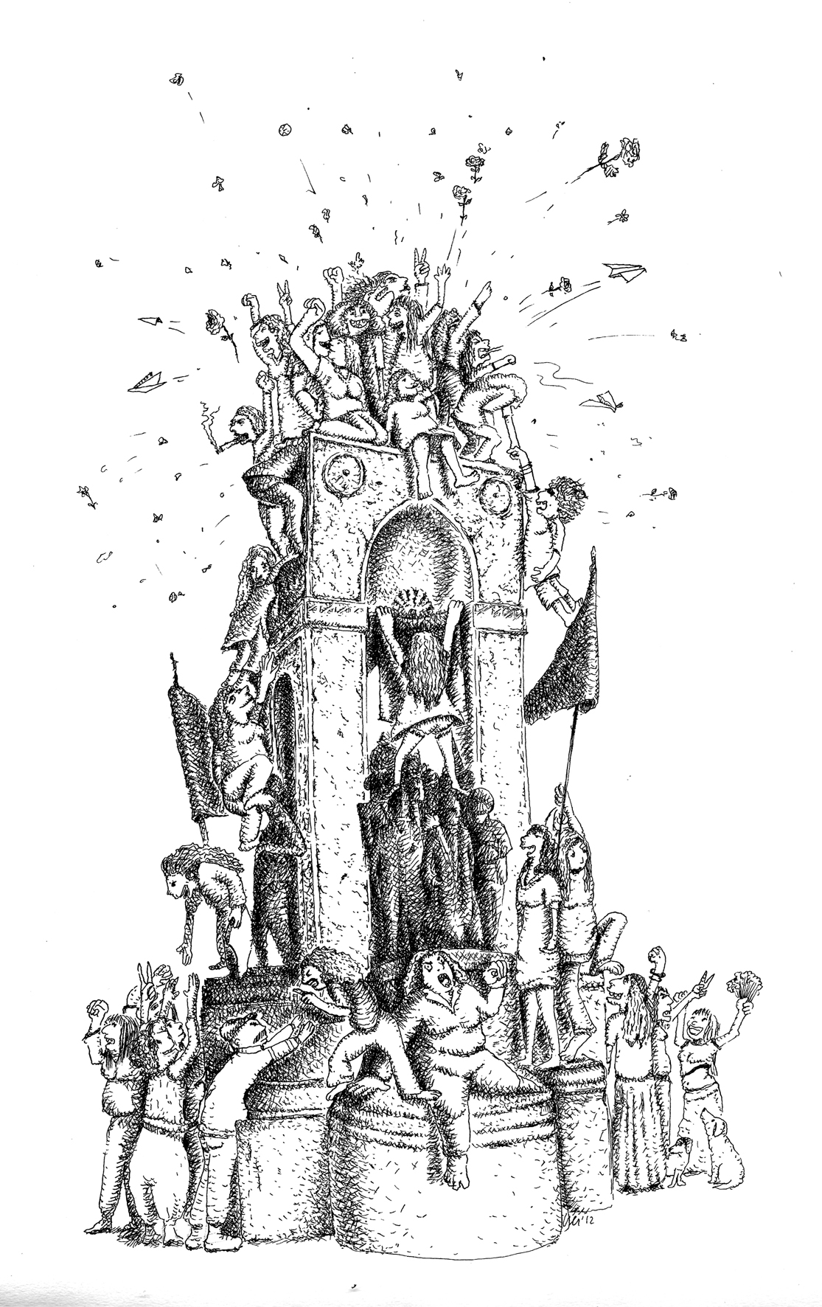

Ceren Oykut, Monument, Ink on paper, 28.5 x 21 cm, 2012

Using various languages, Oykut animates an old and superstitious town, which is sentenced to urban regeneration and has been rebuilt over and over again, and its sleepy residents, who are used to live with all sorts of destruction, violence, and authority.

With its silhouette that is handed over each day under the color of ‘regeneration’, the city reminds us once again that it does not belong to its residents whose elbow room has been getting severely narrower. Oykut magnifies momentary chaos and daily action in her drawings; she wakes up from indistinct moments and takes notes.

Adding a third dimension, Ceren Oykut depicts the ones who are trying to sustain a life sunken into a bird’s eye view of the scenery, flung around, and voiceless. Considering her recent statuettes -which look by no means different from the local soil- and panoramic drawings, one can realize that she is trying to transmit the lonely and unnoticed lives to the audience.

Oykut responds to ever-changing urban life with the stories of people, who keep pace with a district life where the time is less important and are in search for a slow-paced life despite everything that this drift insists on. Making suggestions through a fictional character, who lives in Tarlabasi, tries to find his own solutions, and has distanced himself from money, Oykut points out that an alternative daily life is possible.

Using the spaces and languages of daily life, Ceren Oykut is trying to make the thousands of dreams, which are dragged through the mud, leaf out again like the seeds lying in wait beneath the layers of asphalt and concrete.

In short, who doesn’t give up on humor, Oykut depicts the subconscious of a resident of Istanbul. “Indistinct” will be on view at x-ist until March 30th, 2013.

Artist Biography

CEREN OYKUT
İstanbul, 1978

After graduating from Mimar Sinan University, Fine Arts Faculty, Painting Department in 2002, Ceren Oykut had her first solo show in 2003 “Drawing Exhibition” in Kultur Köln 30, Germany. Oykut’s other solo shows are: “Utopia” (Karaburun Festival, İzmir, 2005), "City Can" (Under Construction Contemporary Art Space, Maltepe, İstanbul, 2006), "City Can" (Under Construction Contemporary Art Space - Kuştepe Branch, Kuştepe, İstanbul, 2006), "Musical Drawings" (Karaburun Festival, İzmir, 2006), "Lost Passport” (Kibla, Maribor, Slovenia, 2008), "Original / No Subtitles" (artSümer, İstanbul, 2010), “With Bells On" (artSümer, İstanbul, 2011). Among the national and international exhibitions, biennials and fairs she participated in are: "Postcards from Stockholm / Istanbul" (Botkyrka Konsthall, Stockholm, Sweden, 2006), "Hafriyat Group Exhibition" (Hafriyat Karaköy, 2007), "Save As.. Contemporary Art From Turkey" (Triennale Bovisa, Milano, İtaly, 2008), "Tracing" (Kasa Gallery, 2009), "Istanbul Traverseé" (Palais Des Beaux Arts De Lille, France, 2009), “Reciprocal Visit” (DEPO, İstanbul, 2009), 10th Istanbul Biennial ("2+1", santralistanbul, 2007), Lyon Biennial 2009 ("La Spectacle du Quotidien", Musee d’Art Contemporain de Lyon, France) and SCOPE Basel 2012 art fair. Invited by Lille 3000 for "I Dream But.." and "İstanbul Traverseé" exhibitions she attended a residency program in France. Oykut also contributes to several periodic publications such as Radikal Kitap, Bant Magazine. Ceren Oykut is featured in the book “Unleashed: Contemporary Art From Turkey” first published in 2010.

